Serverless with AWS Fargate
AWS Fargate is a serverless compute platform for containers that you can use with either ECS or EKS. With AWS Fargate as the compute platform, you run your containers on a managed serverless platform.
- Purpose:
  - AWS Fargate is a serverless compute engine for containers.
- Infrastructure Management:
  - Abstracts away EC2 instances — no need to manage servers or cluster capacity.
  - Automatically allocates the right amount of compute resources.
- Compatibility:
  - Works with existing Amazon ECS concepts, APIs, and integrations.
- Security & Networking:
  - Natively integrates with IAM for access control.
  - Integrates with Amazon VPC to launch containers inside your private network and control connectivity.
- Key Benefit:
  - Developers can focus on application development, while AWS handles scaling and infrastructure management.

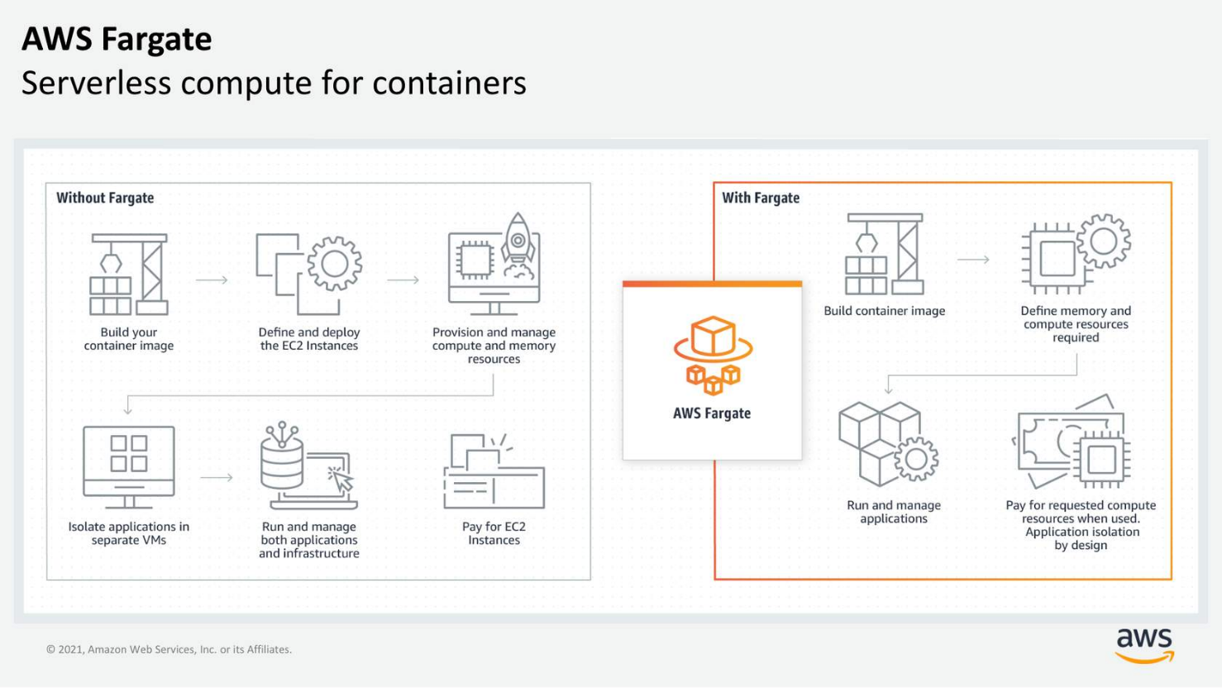

Resources
For more information, see the following resources:
- AWS website: AWS Fargate(opens in a new tab)
- AWS website: Getting Started with Serverless Computing(opens in a new tab)
- External site: Coursera course: Building Modern Python Applications on AWS

